Data Transfer

BioLink Data Transfer 1
The BioLink XML Format 1
Exporting Data From a BioLink Database 1
Importing Data into a BioLink Database 2

BioLink Data Transfer
The BioLink data transfer facility allows data from one BioLink database to be transferred to another (or the same) BioLink database. Tags are included to uniquely identify the items being transferred. During import, these tags are used to update items found in both the database and the information being imported. Information not found in the database will be added as new records. This means that, for example, subsets of a BioLink database can be transferred to another database, changes made to this copy, and the copy imported back into the original BioLink database without data loss or duplication. This can be especially useful when working on a subset of a large BioLink database “off line”, for example while traveling to collections. The subset can be updated during collection visits and imported back into the original BioLink database on return. This is important when network access to the main BioLink database isn’t available while traveling.

The BioLink XML Format
The XML format used by BioLink is tied closely to the data model used within the BioLink database. This has the advantage that all BioLink elements and data items can be represented and therefore transferred. Since this information is stored as XML a wide range of tools are available for examining, creating and modifying the data. This means that information from other systems can be fully imported into BioLink if it is first exported into the BioLink XML format. An example of such a utility is a Platypus-to-BioLink transfer program developed by the BioLink Team.

Exporting Data From a BioLink Database
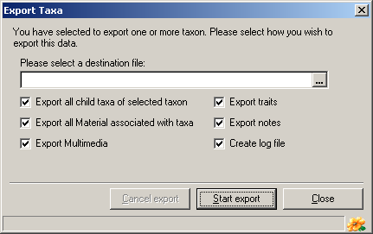
Information is exported from a BioLink database for a taxon or a set of taxa. To export data, open the Taxon Explorer, select a taxon or set of taxa (using multiple select), open the Edit menu or click the right mouse button and select the Export command. This will open the Export Taxa window. This window allows a number of options to be set. These include the name of the XML destination file and the information to be exported. This information is selected with a series of check boxes. Once the appropriate information has been entered press the Start Export button to export the information.

Importing Data into a BioLink Database
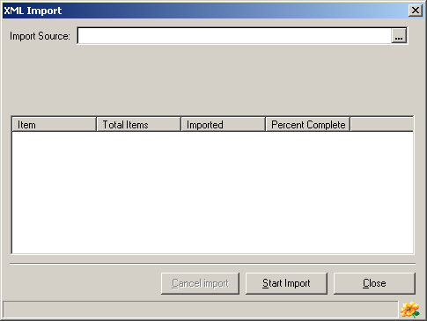
To import information into a BioLink database click the XML I/O button on the main BioLink toolbar. This will open the XML Import window. Enter the name of the XML file to import in the text field near the top of the window. Pressing the ellipsis button to its right will open a File Open dialog box. Once the file name has been entered press the Start Import button. This will begin the import process. The number of items being imported along with the status of the import will be displayed in the lower section of the window. Once complete, press the Close button to close this window and return to BioLink.

